**Report - Cyberslacking Group 3**

The dataset includes several variables that could be relevant to understanding the factors influencing cyberslacking and increased security risks. Here are the main categories and variables available in the dataset:

1. **Environmental Factors**:

* Facilitating Condition
* Subjective Norms
* Organizational Justice

1. **Personal Attitudes and Abilities**:

* Attitude toward Cyberslacking
* Cyberslacking Self-Efficacy
* Conscientiousness
* Personality Traits

1. **Work-Related Factors**:

* Job Stress

1. **Outcome Variables**:

* Cyberslacking
* Increased Security Risk

1. **Demographic Variables**:

* Gender
* Age
* Education
* Monthly Income
* Work experience in business organization

**Distribution by Demographics:**

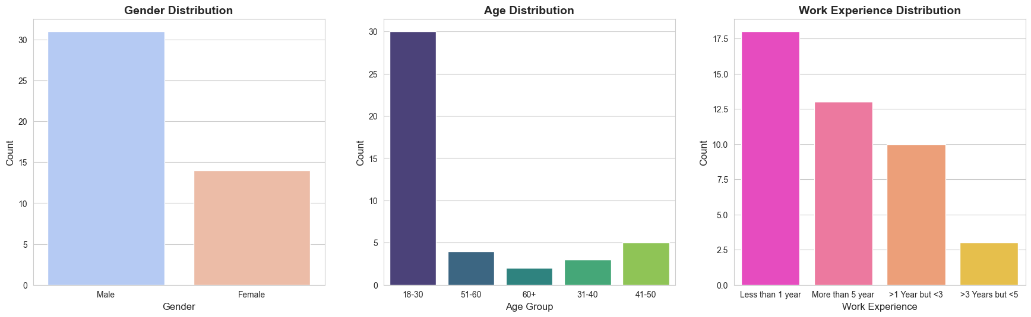

* **Gender**: Predominantly Male (31 out of 45).
* **Age**: Most respondents are in the 18-30 age group (30 out of 45).
* **Education**: Majority have a post-graduate education (26 out of 45).
* **Monthly Income**: Most earn below 25,000 BDT (17 out of 45).
* **Work Experience**: A significant number have less than 1 year of experience (18 out of 44).

**Data Manipulations**

1. Assign numerical values:

* Strongly Agree / Agree = 1
* Neither agree nor disagree = 2
* Disagree / Strongly Disagree = 3

1. Create columns for different sections:

* Facilitating Condition
* Subjective Norms
* Organizational Justice
* Attitude toward Cyberslacking
* Cyberslacking Self-Efficacy
* Conscientiousness
* Personality Traits
* Job Stress
* Cyberslacking
* Increased Security Risk

1. Calculate average values for each section based on the questionnaire responses.
2. Round the averages to the nearest whole number to reflect the categorical nature of responses.
3. Encode the remaining demographic variables using label encoding for each categorical variable.
4. Begin data analysis using the rounded average values for each section.

**Correlation Analysis**

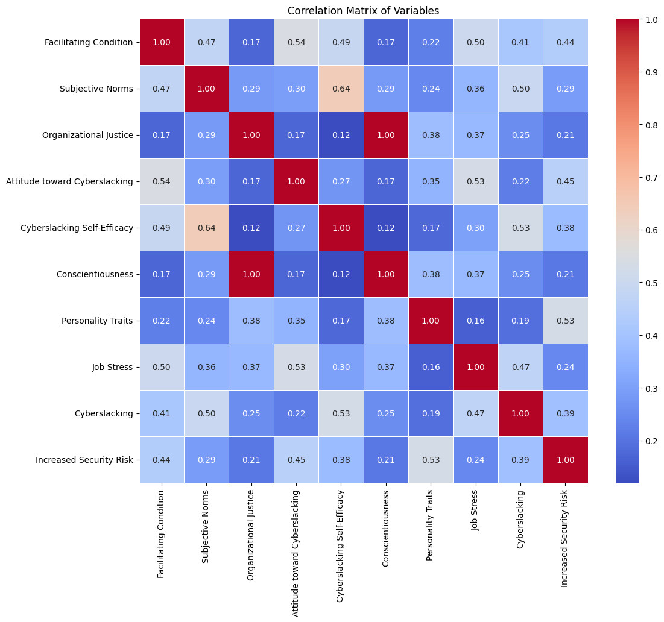

**Table 1: Correlations with Cyberslacking (Top 3 Factors)**

|  |  |
| --- | --- |
| Variable | Correlation with Cyberslacking |
| Cyberslacking Self-Efficacy | 0.53 |
| Subjective Norms | 0.50 |
| Job Stress | 0.47 |

**Table 2: Correlations with Increased Security Risk (Top 3 Factors)**

|  |  |
| --- | --- |
| Variable | Correlation with Increased Security Risk |
| Personality Traits | 0.53 |
| Attitude toward Cyberslacking | 0.45 |
| Facilitating Condition | 0.44 |

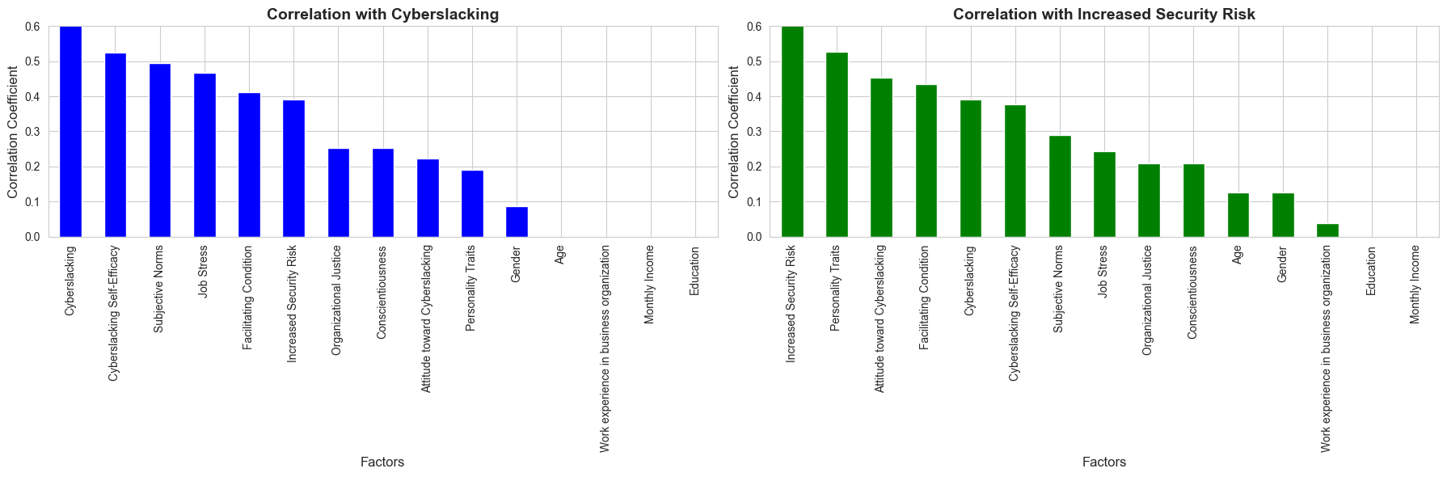

**Correlation Analysis Results from the Heatmap:**

* **Factors related to Cyberslacking**:
  + **Cyberslacking Self-Efficacy (0.53)**: Indicates a moderate positive correlation with cyberslacking behaviors.
  + **Subjective Norms (0.50)**: These show positive correlations suggesting subjective norms influence cyberslacking.
  + **Job Stress (0.47)**: Positively correlated, indicating that higher job stress may lead to more cyberslacking.
* **Factors related to Increased Security Risk**:
  + **Personality Traits (0.53)**: Moderate positive correlation, suggesting traits significantly influence perceived security risks.
  + **Attitude toward Cyberslacking (0.45)** and **Facilitating Condition (0.44)**: Showing moderate positive correlations, linking both to increased security risks.

**Recommendations from the Data Analysis for Reducing Cyberslacking and Mitigating Security Risks**

* **Enhance Awareness and Training Programs:**
  + **Objective:** Address attitudes towards cyberslacking by implementing targeted awareness programs.
  + **Actions:** Develop training modules that explain the negative impacts of cyberslacking on productivity and security.
* **Strengthen Organizational Policies:**
  + **Objective:** Enforce clear and firm policies regarding acceptable online behaviors at work.
  + **Actions:** Review and update the existing internet usage policies to include specific examples of what constitutes cyberslacking.
* **Supportive Work Environment:**
  + **Objective:** Reduce job stress, which has been identified as a correlating factor with cyberslacking.
  + **Actions:** Promote work-life balance through flexible work schedules and mental health days.
* **Develop Personal Development Plans:**
  + **Objective:** Address personality traits and self-efficacy factors that contribute to increased security risks and cyberslacking.
  + **Actions:** Offer personality development training that helps employees enhance traits such as conscientiousness and responsibility.